**What to Do If the Touch Screen on Your iPhone Isn't Working?**

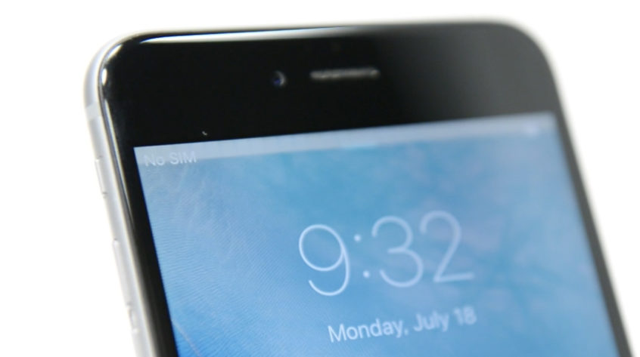

A new virus is making its way across the cell phone community. Many iPhone 6 and iPhone 6 Plus customers have been affected by a new 'sickness.' This situation irritates, perplexes, and even enrages users, causing them to worry!

**"My phone isn't functioning anymore!"**

Those are four horrible phrases you don't want to speak to yourself. Unfortunately, the "Touch Disease" has done exactly that for many iPhone 6 and iPhone 6 Plus customers. This flaw can render your phone useless, preventing you from calling your mother, texting your husband, or even snapping with your pals!!! Is your iPhone's touch screen malfunctioning? Continue reading if you answered yes.

**What is "Touch Disease" and how does it affect you?**

If your iPhone 6 or iPhone 6 Plus begins to perform one (or all) of the following three behaviours, it's reasonable to assume that your phone has contracted "Touch Disease":

* When the touch screen begins to flicker, it is an indication that something is wrong.
* The top of the screen displays a grey bar.
* The touch screen stops responding.

Despite the fact that Apple has never referred to this flaw as "Touch Disease," they have acknowledged its presence. "Apple has discovered that some iPhone 6 Plus devices may show display flickering or Multi-Touch difficulties after being dropped many times on a hard surface and then undergoing further stress on the device," the company said in a statement. It's worth noting that Apple only mentions the iPhone 6 Plus, not the iPhone 6. However, there have been reports of iPhone 6 units contracting the "Touch Disease."

**The Cause of Touch Disease:**

You know what occurs when an iPhone gets "Touch Disease," but what caused the phone to go bad in the first place? A Logic Board (the primary circuit board) and two Integrated Circuits are found within every iPhone 6 and iPhone 6 Plus (also known as IC Chips). Touching the screen triggers an action thanks to the IC Chips.

The Logic Board can flex under stress (regular use or dropping the phone repeatedly). When the Logic Board bends, the IC Chips can get separated from the Logic Board, rendering the touch screen inoperable.

The inability to operate an iPhone's touch screen might be the most aggravating condition conceivable. Customers have come through our doors on the edge of sobbing because they were unable to 'like' their friend's Facebook post. You don't want to be in their shoes, believe us.

**Who can fix my phone and how is Touch Disease treated?**

"Touch Disease" can be treated in two ways. Either the Logic Board or the IC Chips must be re-soldered onto the logic board. You won't be able to achieve this by yourself. As a result, you'll need to get your iPhone fixed by a professional.

Repairs to the motherboard, similar to IC Chip repairs, are done at the board level. Other IC Chips beyond the TOUCH IC Chip are available. These additional IC chips can be changed at M6 Repairs board repair centre if they are genuinely damaged.

Apple recently launched a repair program to treat the "Touch Disease". It costs £110. This only applies to iPhone 6 Plus. Apple won't repair your phone if the phone has been damaged in any way. What about iPhone 6 Plus users? Don't fret. M6 Repairs has expert technicians who can repair any model of iPhone 6 or iPhone 6 Plus smartphone.

Although Touch Disease is more common in the iPhone 6 Plus model, it can also affect the iPhone 6 model. Apple will not assist you with your iPhone 6 model, as we have already stated. [M6 Repair](https://m6repair.co.uk/) will help you with the touch disease.